+



**COLLEGE OF COMMERCE SCIENCE AND**

**INFORMATION TECHNOLOGY, PIMPRI, PUNE**

***SAVITRIBAI PHULE PUNE UNIVERSITY***

**Research Work**

***On***

**“ A Case Study of AI-Driven Smart**

**Ticketing Systems”**

**By**

***Miss. Pawar Payal Yashwant***

***Miss. Narawade Vrushali Suresh***

**Under the guidance of**

***Prof. Sarika Shinde Mam***

**In partial fulfillment of**

**S.Y.MSc( Computer Science)**

**Academic Year 2024-2025**



This is to certify that **Pawar Payal Yashwant**

students of S.Y.MSc.(cs) SEM-III course have

satisfactorily completed the CS- 631-RP/ Research Work

– I entitled as **“ A Case Study Of AI Driven Smart**

**Ticketing System”** in the partial Fulfilment of **Master**

**of Science (Computer Science)** course during the

academic year 2024-25.

**Project Guide H.O.D. Principal**

**Internal Examiner External Examiner**

**Index**

|  |  |  |
| --- | --- | --- |
| **Sr.No** | **Title** | **Page No** |
| 1 | List of figures |  |
| 2 | Introduction:Objective of research |  |
| 3 | Literature Reviews of previous research in area |  |
| 4 | Data collection |  |
| 5 | Actual work done |  |
| 6 | Result |  |
| 7 | Future Scope |  |
| 8 | Limitation |  |
| 9 | Bibliography |  |

**List Of Figure**

* Diagram of Facial Recognition Workflow in Metro Systems

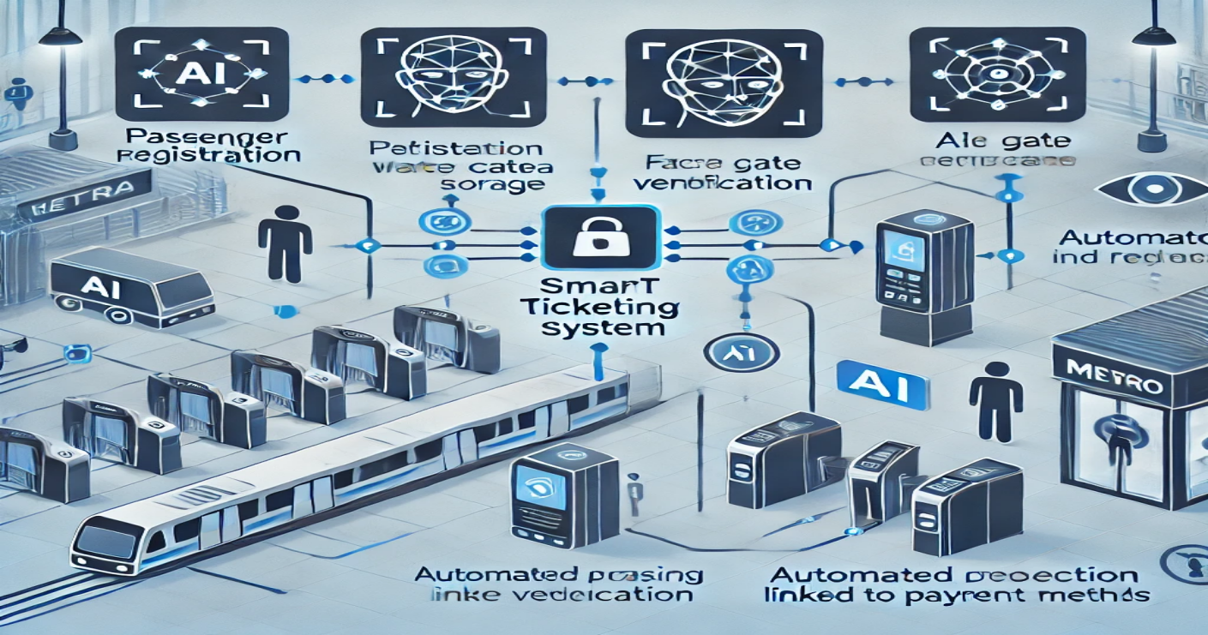

**Introduction**

The integration of Artificial Intelligence (AI) and facial recognition technology into smart ticketing has transformed urban transportation, particularly within metro systems. Traditional ticketing methods—such as paper tickets, magnetic cards, and QR codes—are often inefficient and susceptible to delays and security issues. Facial recognition, however, provides a streamlined, secure, and efficient alternative, reshaping how passengers interact with public transit.

Facial recognition technology identifies individuals by capturing and analyzing unique facial features. Paired with AI, it processes and matches faces in real time, making it an ideal solution for modernizing ticketing and access control. In metro stations, AI-driven facial recognition enables passengers to enter and exit without physical tickets or cards; instead, passengers’ facial features are linked to accounts containing their payment and travel details.

These systems promise to not only streamline travel but also make metro and public transit systems more responsive, secure, and sustainable. This case study explores how AI and facial recognition are reshaping metro ticketing, addressing the benefits, challenges, and future outlook of this innovative technology in urban transit.

**Objective**

* Enhance Passenger Convenience: Facilitate smooth entry and exit without requiring physical tickets, cards, or apps, thereby reducing wait times and easing congestion.
* Improve Security: Use facial authentication to verify identity, preventing fraud and unauthorized access.
* Increase Operational Efficiency: Use AI to monitor passenger flow and travel data in real time, optimizing station operations and fare calculations.
* Provide Real-Time Analytics: Gather and analyze data on passenger behavior and traffic patterns to enhance scheduling, resource allocation, and station management.

**Literature Review of previous research**

|  |  |
| --- | --- |
| Artical | International Journals |
| 4 | 4 |

**Data Collection**

This section outlines the framework for data collection, detailing the methods, sources, and techniques employed to gather relevant information.

**Types of Data**

Data collection for this research will focus on both qualitative and quantitative data to provide a comprehensive understanding of AI-driven smart ticketing systems.

Quantitative Data: This includes numerical data that can be statistically analyzed.

* User adoption rates of smart ticketing systems.
* Frequency of fare evasion incidents before and after implementation.
* Average waiting times at ticketing stations.
* User satisfaction ratings collected through surveys.

Qualitative Data**:** This involves non-numerical data that provides insights into user experiences, perceptions, and attitudes toward smart ticketing systems.

* User feedback through open-ended survey questions.
* Interviews with stakeholders, including transit authorities, technology providers, and passengers.
* Analysis of case studies from cities that have implemented smart ticketing solutions.

**Data Sources**

**Primary Sources**

Surveys:

Structured surveys will be administered to users of metro systems to gather quantitative data on their experiences and perceptions of smart ticketing systems. Surveys will be designed to include both closed and open-ended questions to capture a broad range of feedback.

Interviews:

Semi-structured interviews with key stakeholders, including metro authorities, technology vendors, and passengers, will provide qualitative insights into the implementation process, challenges faced, and user acceptance of smart ticketing technologies.

Observational Studies: Observations of user interactions at ticketing stations will be conducted to assess the efficiency and effectiveness of smart ticketing solutions in real-world settings.

**Secondary Sources**

Literature Review:

Previous research studies, industry reports, and academic articles will be reviewed to gather insights into existing knowledge and theoretical frameworks related to smart ticketing systems.

Government and Transit Authority Reports:

Data from public transportation agencies, including annual reports and performance metrics, will provide valuable quantitative information on system efficiency, user demographics, and operational costs.

**Data Collection Techniques**

Survey Design:

Surveys will be designed using established frameworks to ensure validity and reliability. Online survey platforms will be utilized to reach a diverse audience and facilitate data collection.

Interview Protocols:

A structured interview protocol will be developed, outlining key questions to be addressed while allowing for flexibility to explore emerging themes. Interviews will be recorded (with participant consent) and transcribed for analysis.

**Actual Work Done**

User Registration:

Facial Recognition: Users register through a metro app where their facial image is captured and stored securely in the system.

Mobile Integration:

Users can also link their mobile devices (via QR code, NFC, or mobile app) to their account for ticketless travel.

Ticket Purchase or Verification:

Mobile App: Users purchase a ticket through the app by selecting travel routes and paying via digital payment methods (e.g., credit card, e-wallet).

AI Authentication: For users enrolled in facial recognition , AI automatically verifies their identity at the metro gate, eliminating the need for physical tickets.

Entry to Metro:

Facial: At the metro entrance, AI cameras scan the user’s face . Once verified, the gates open automatically.

Mobile Ticketing: Users with mobile tickets can confirm the source to destination point or use NFC on their phone to gain access.

In-Transit Monitoring:

AI Fare Calculation: AI tracks the journey, and in some systems, the fare is calculated dynamically based on the distance traveled.

Exit from Metro:

Facial Authentication: The AI system verifies the user’s identity again at the exit gates, allowing them to leave without presenting a physical ticket.

Mobile App:

Users with mobile tickets scan their phone again or rely on the AI-based Bluetooth Low Energy (BLE) system to detect their phone and open the gates.

**Result**

1. **Increased Efficiency :**The system reduced boarding and exit times by eliminating the need for physical tickets or card scanning ,speeding ip passenger flow through stations .

**2.User Experience :**Passengers reported higher satisfaction due to the seamless and contactless travel experience with fewer delays .

**3.Operational Insights**:The system provided real-time data on passemger flow ,allowing for better management of station congestion and optimized train scheduling .

**4.Revenue Accuracy :**Fare calculations based on travel distance or zones were more accurate ,leading to fairer pricing and optimized revenue generation .

**Overall Impacts:**

1. The implementation of AI-driven smart ticketing systems has demonstrated considerable positive impacts on user experience and operational efficiency in metro networks.
2. The results indicate that these technologies can significantly enhance the ticketing process, reduce fare evasion, and increase overall user satisfaction.
3. However, addressing privacy concerns and ensuring user education remain critical for maximizing the benefits of these systems.

**Future Scope**

1. **Scalability and integration:**Future research can explore the scalability of AI-driven facial recognition systems across larger metro networks and integration with other transportation systems like buses and tams for a unified travel experience .
2. **Enhanced Algorithms** **:**Developing more advanced AI algorithms that improve facial recognition accuracy .

**3.Privacy and Ethics:** Further studues are needed to address ethical concerns related to facial recognition .

**Limitation**

1. **Initial Cost:**High stup costs for implementing facial recognition systems ,including infrastructure ,software and hardware requirements can be a barrier for smaller metro systems .
2. **Environmental Factors :**The accuracy of facial recognition can be affected by environmental factors like facial obstructions

Or camera quality.

3.**System Maintenance** :Ongoing maintenance and updates to the facial recognition system,including database management and software adjustments are required to ensure long term effectiveness and security.

**Bibliography**

* Ratha.N.K.,Bolle,R.M.,&Jain,A.K.,”Biometric Recognition:Challenges and Opportunities ,”IEEE Transactions on Systems ,Man ,and Cybernetics,2004.
* Nguyen,H.,&Aspley,T.,”AI-Powered Facial Recognition in Smart Transportation Systems,” Journal of Transportation Technology,2019
* Zhao,W.,Chellappa,R.,Phillips,P.J.,&Rosenfeld,A.,”Face Recognition:A Literature Survey,” ACM ComputingSurveys ,2003.
* Jain,A.K.,Ross,A.,&Nandkumar,K.,”Introduction to Biometrics ,”Springer ,2011.